Problem Set 7: GIS Data Collection

Exercise 1: Using the NJDEP Open Data Site

Assignment 1.1
Map layout attached at the end

Exercise 2

Assignment 2.1
- 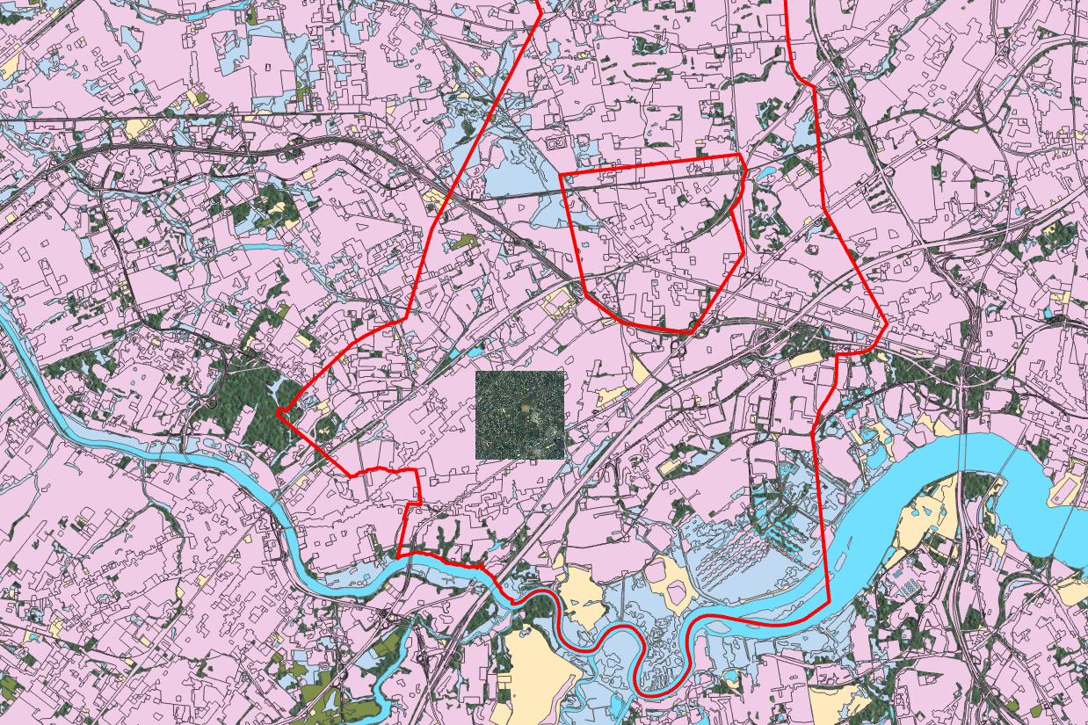

Assignment 2.2
- 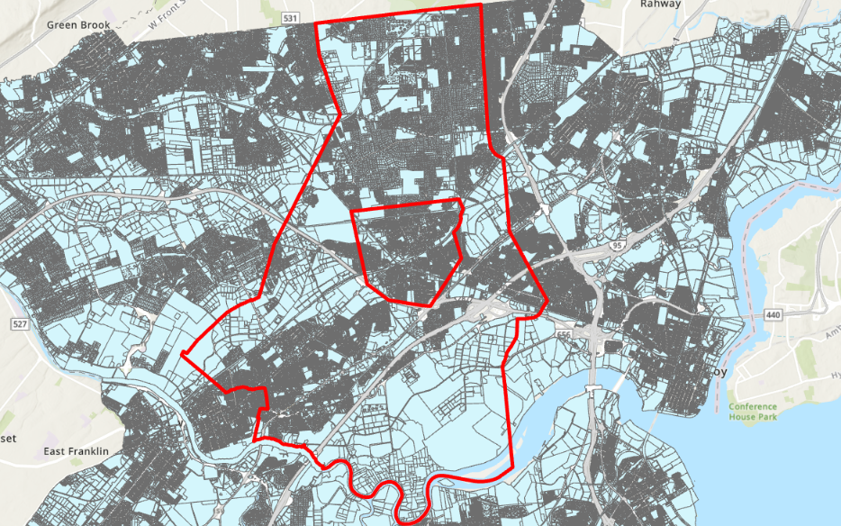

Exercise 3: Using Social Explorer

Assignment 3.1
- What was the “average household size” in Hudson County in 2010? How does it compare to New Jersey? And to that of the US as a whole?
  - Average household size
  - US - 2.58
  - NJ - 2.68
  - Hudson County - 2.54

Assignment 3.2
- 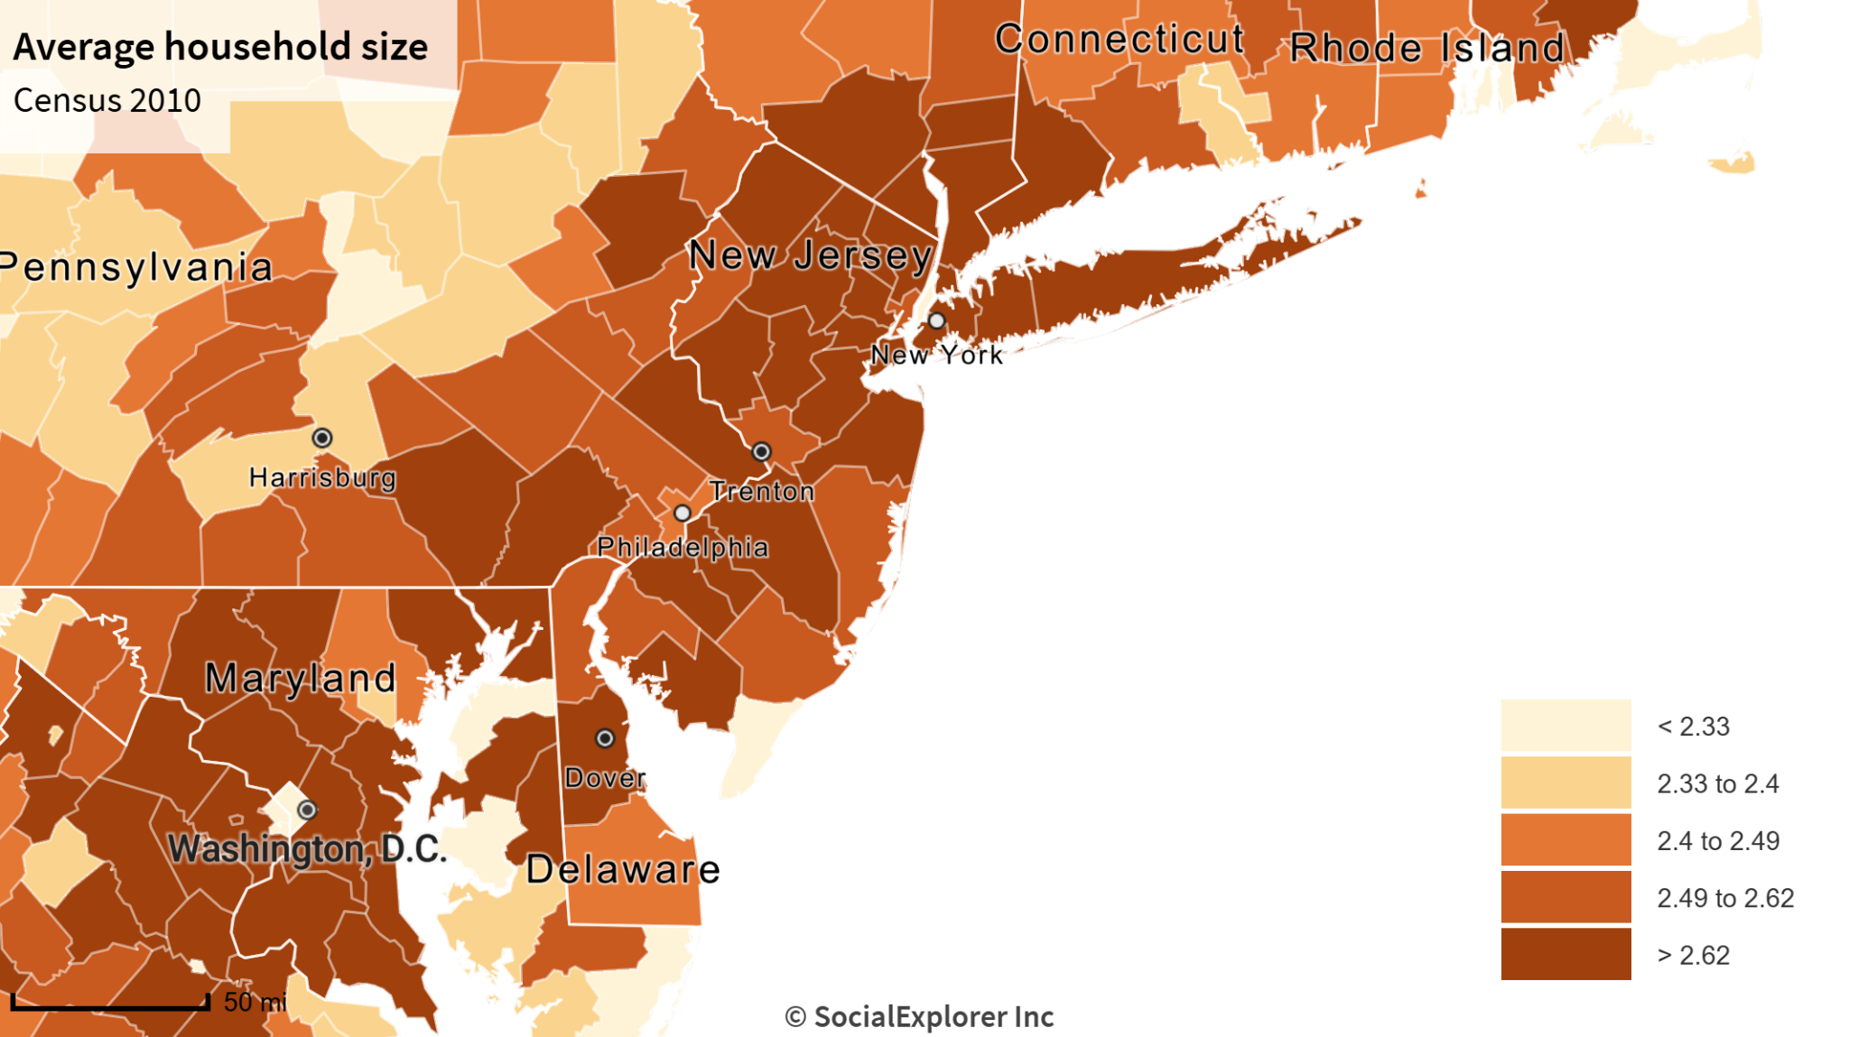
- What spatial pattern do you see within New Jersey and the region around it? Explain
  - Household sizes are bigger in the urban areas closer to NYC and Philadelphia, and smaller in the coastal and southern counties.

Exercise 4: Using PolicyMap

Assignment 4.1
- What are the 2019-2023 median home values in Princeton and New Brunswick (hint: use the search bar to find each of these cities, and make sure you adjust your choropleth in the bottom left to be “Shaded By: City” instead of Census tract before you check the value)?
  - Princeton: $1,040,400
  - New Brunswick: $316,800
- How do they compare to the state and national median home values (you’ll have to type new locations into the search bar)?
  - NJ: $427,600
  - US: $303,400

Assignment 4.2
- What is the source for this data (name and year)?
  - 2019-2023 U.S. Census American Community Survey (ACS)
- Do the choropleth class breaks on the map work well for this part of New Jersey? Why or why not?
  - Yes, they work pretty well. They allow for us to see the large-scale house value trends in the state, especially the higher value of homes along US-1 highway that connects NYC to Philadelphia.

Assignment 4.3
Map attached at the end of the document

Assignment 4.4
- Do the rates of uninsured individuals for Census tracts in New Brunswick seem high?
  - Yes, there are several tracts with 30-40% of the population being uninsured.
- Which parts of the city have the highest rates (you might have to turn off city boundaries to see the data since tracts cross municipal boundaries)?
  - The eastern parts of the city have the highest percentage of uninsured people
- What is the total uninsured rate for New Brunswick, and how does it compare to the county, the state, and the country?
  - Total uninsured rate
    - New Brunswick: 21.45%
    - New Jersey: 7.44%
    - USA: 8.55%

